**Are you ready for college and life after high school??**

Step 1: Logging In

* Go to <https://student.naviance.com/chesapeakehs>
* Log in to Naviance using the following:
  + Username = 6-digit student ID#, for example 123456
  + Password = firstnamelastname2023, for example kristingibbons2023

Step 2: Updating Your Information

* Click on “About Me” located in the upper right-hand corner
* Select My Account located under your name
* Review the information listed under General Information and Parents/Guardians
* When you’re in General Information, please make sure the e-mail listed is YOUR e-mail
* To make changes, click 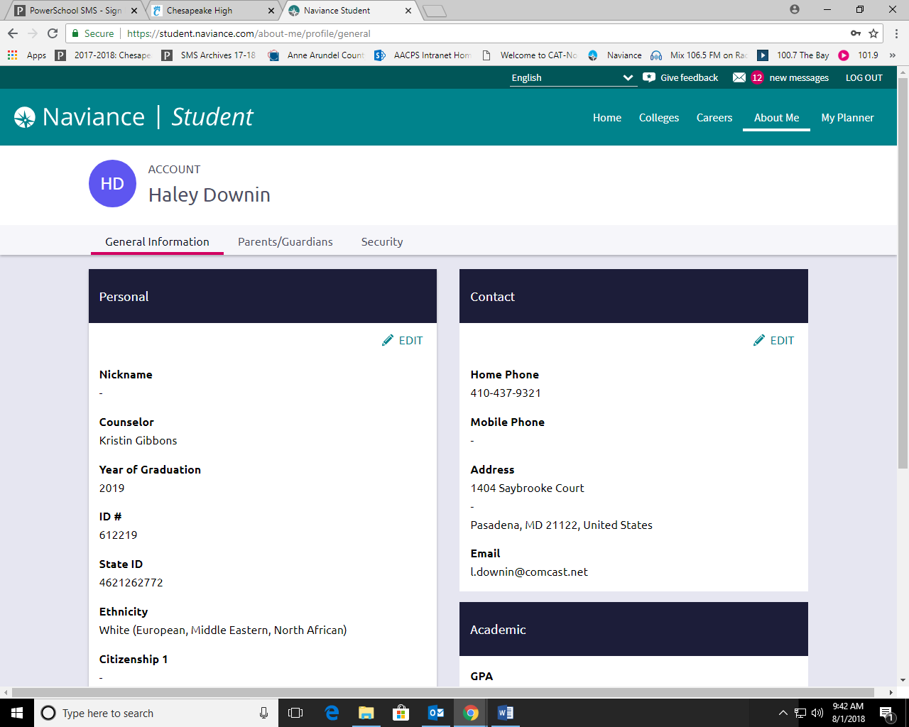
* Click the save button when completed

Step 3: Complete Autobiographical Sketch

* Click on “About Me” located in the upper right-hand corner
* Then select Home
* Click on “Autobiographical Sketch – for counselor rec” under Surveys to Take
* Please answer **all** of the questions with as much detail as possible – this will help your counselor with her letter of recommendation
* Click the “Update” button to save your changes

*There are many items on Naviance that will help you through the college process!*

You can…

* Sign up for college visits
* Access college searches on Naviance
* Link the Common App with Naviance
* Apply to college using Naviance
* Request teacher recommendations
* Requests transcripts

To sign up for a college visit, you must:

1. Sign into Naviance
2. Click on “Colleges” located in the upper right-hand corner
3. Then select Home
4. Scroll down until you see College Visits
5. Select “Show More” button
6. Click the “Register Now” button
7. You will receive a pass on the day of the college visit
8. REMEMBER: you can **only** attend 3 college visits here at CHS

To add a college to the “Colleges I’m Applying To” list:

1. Sign into Naviance
2. Under “My Favorites”, click “I’m applying to” under “Colleges”
3. Under “Colleges”, click “I’m applying to”
4. Click 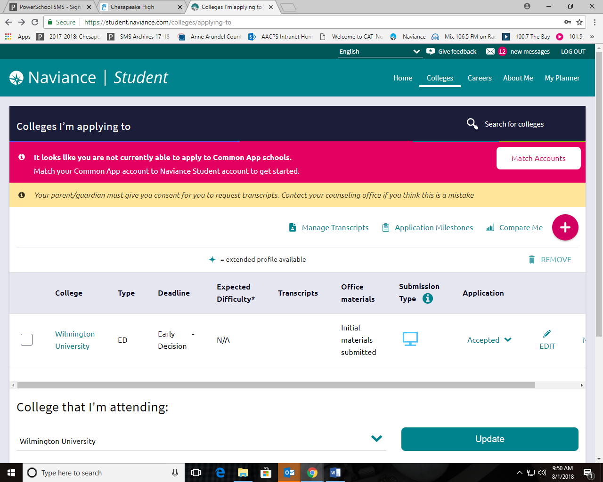
5. In the drop-down menu, either select or search for your college
6. Indicate your decision type using the drop-down menu
7. Indicate how you’re applying using the drop-down menu
8. Select the “ADD AND REQUEST TRANSCRIPT” button to save your school to the list as well as request a transcript

**Please complete the “Transcript Request Form” found in the “CHS College Process” folder under the Document Resources link on the home page of Naviance. Then, submit it to Ms. Wilson in the Counseling Office along with **$2 per transcript**\*\*

1. If needed, repeat steps 4-8 to add more colleges to your list
2. You can then begin your college applications

To link your Common Application to your Naviance account:

1. Go to [www.commonapp.org](http://www.commonapp.org) and create an account – **your name must match exactly with your name in Naviance**
2. Once you have created your account, click on the “Common App” tab
3. Complete the “Education” portion of the Common App
4. Click on the “College Search” tab
5. Search for colleges by typing in the name, location, distance from home, etc.
6. Click the “Search” button
7. Under “Result List”, click the box to the left of the college(s) name that you are interested in applying to
8. Click the “Add” button
9. Click on the “My Colleges” tab
10. Click on “Recommenders and FERPA” and follow the steps – make sure you **DO** waive your rights
11. Sign into Naviance
12. Under “My Favorites”, click “I’m applying to” under “Colleges”
13. Under “Colleges”, click “I’m applying to”
14. There will be a pink bar located towards the top of the screen, click the “Match Accounts” button
15. Enter the e-mail address you used to create your Common App account
16. Click on the “Match Accounts” button
17. Now, you are ready to finish your Common App applications!

**PLEASE make sure the colleges listed in your Common App show up in Naviance**

To request a teacher recommendation:

1. **ASK YOUR TEACHER FACE-TO-FACE TO PLEASE WRITE A LETTER OF RECOMMENDATION**
2. Sign into Naviance
3. Click on the “Document Resources” link located towards the bottom of the page
4. Open CHS College Process folder
5. Complete the “Letter of Recommendation Request Form”. Give the Request Form to your teacher either via e-mail or face-to-face and confirm that he/she can write a recommendation
6. Click on “Colleges” located in the upper right-hand corner
7. Click on “Home” located under “COLLEGES”
8. Scroll down until you see the section “Apply to Colleges”
9. Click on “Letters of Recommendation”
10. Click the 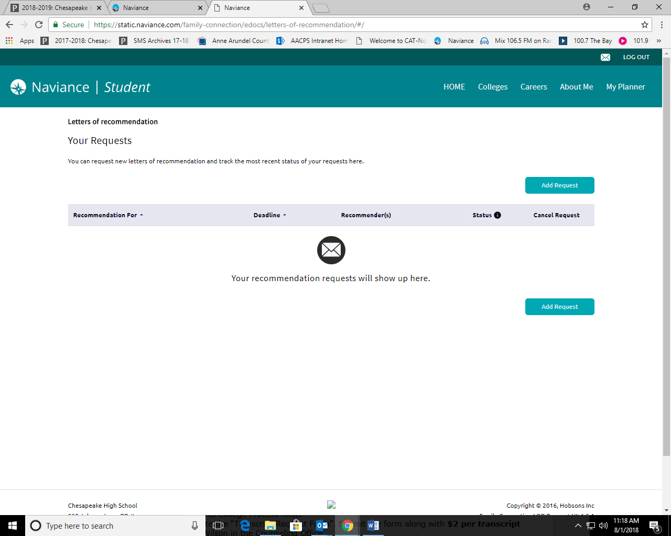button
11. Question 1: Use the drop-down menu to select your teacher – the list is organized alphabetically by teacher last name
12. Question 2: Select which colleges this request is for – Choose **specific** colleges from your *Colleges I’m Applying To* list or All current and future colleges I add to my *Colleges I’m Applying To* list
13. Question 3: Include a personal note to your recommender
14. Click the 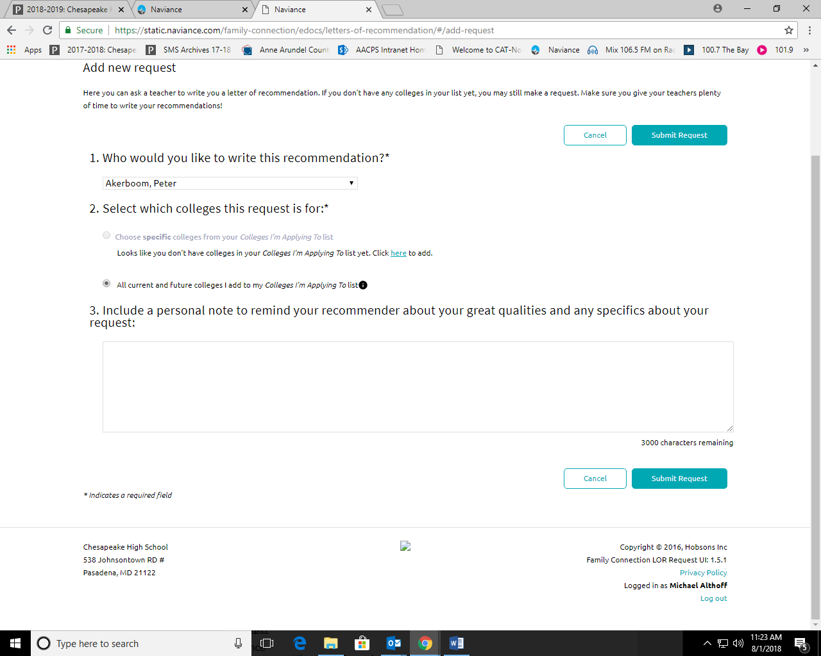button
15. Repeat steps 10-14 for all teacher requests you want to make

To request a transcript:

1. Sign into Naviance
2. Click on the “Document Resources” link located towards the bottom of the page
3. Open CHS College Process folder
4. Complete the “Transcript Request Form”. Submit the form along with **$2** **per transcript** to Ms. Wilson in the Counseling Office
5. Click on “Colleges” located in the upper right-hand corner
6. Click on “Apply to College”
7. Click on “Manage Transcripts”
8. Click 
9. Select “College Application Transcript” or “Other Transcript” (for NCAA, scholarships, etc.)
10. Answer the questions, then select the 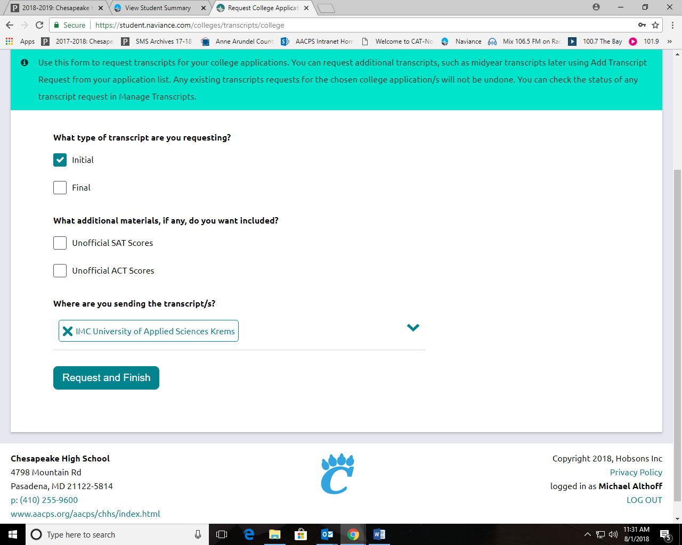button